Ellen Kozlowski is the new Technical Assistant for SE Regional CSP

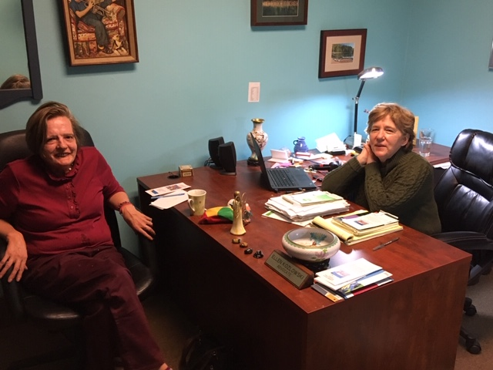
Ellen Kozlowski, at the desk, with Hope Market volunteer, Monica.

I’m thrilled to be the new Technical Assistant for the Southeast Regional Community Support Program (CSP) Committee. I began the job in August and I’m looking forward to working with the committee and the Executive Committee to assist and support the committee members’ ideas, vision and activities.

For the past 13 ½ years, I’ve worked as an advocate for Community Advocates of Montgomery County which is an affiliate of Hopeworx, Inc. I assist adults living in the county who have mental health issues with needs they may have regarding services, treatment, housing, employment and basically whatever they are striving to achieve.

I have also been a member of the regional committee for the past 15 years, serving as treasurer for several years. I’ve been an active member of the Advocacy Subcommittee which addresses issues from the PA legislative budget to mental health parity in health insurance.

I will continue my full time job as advocate. My additional responsibilities will include the job of the Technical Assistant. I will coordinate planning among the five counties in the region – Montgomery, Delaware, Philadelphia, Bucks and Chester – and support the county liaisons by providing information and coordinating activities. I am also part of the Executive Committee.

The SE Regional CSP Committee is a group of mental health stakeholders – peers, family members, families and professionals – who meet monthly to improve mental health services and promote awareness and education across southeastern Pennsylvania. For more information about the committee, go to the Montgomery County CSP website: https://www.montcopacsp.org/regional-and-state-committees.

