
CST ANNUAL REPORT 2018
Prepared by: The Consumer Satisfaction Team – April 2019
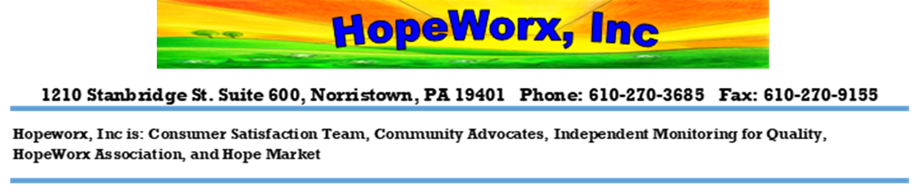
Contents
About CST
Who We Are 3
Mission 3
What We Do 3
Meet the CST Members 4
Survey Process
Scope of Work & Creating Survey Tools 5
Contacting Providers & Conducting Interviews 5
Compiling, Analyzing Data & Creating Reports 6
Sharing Information with the Stakeholders 6
2018 SCOPE OF WORK
CST Projects 7
CHIPPS 7
Career Center Services 16
In-Patient Psychiatric Hospitals 20
ACT Teams 30
2018 State Question Results 32
COMMUNITY SUPPORT PROGRAM (CSP)
Montgomery County CSP 33
Southeast Regional CSP 33
CST STAFF DEVELOPMENT
Trainings and Community Development 34
CST SWOT Analysis 36
Source 37

ABOUT CST

Who We Are

The Consumer Satisfaction Team (CST) of Montgomery County, at HopeWorx, Inc., is funded by the Montgomery County Department of Behavioral Health and Developmental Disabilities (BH/DD). CST is a group of people with varied experiences in mental health recovery. We strive to create a safe space for people to self-advocate for their needs, because each individual is an expert on themselves. Through our diversity we are able to meet people where they are at in their recovery and have conversations about their experience and satisfaction with the Montgomery County, PA mental health system.

Mission
The central role of CST is to provide the Montgomery County Office of BH/DD with information about people’s experience and satisfaction with the mental health services that adults are receiving and to make recommendations for change.

What We Do
CST is contracted by the Montgomery County Office BH/DD to meet predominately person to person with people to listen and document their degree of satisfaction with the services that are funded by the Montgomery County Behavioral Health System. We use survey tools developed by the members of CST, which are designed specifically for each service. The people surveyed are adults 18 years and older and are residents of Montgomery County, PA.
“We strive to create a safe space for people to express themselves respectfully by self-advocating for their needs and belief that they are the expert on themselves.”

MEET THE CST Members
  Anise Mibourne | 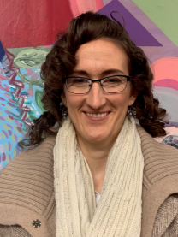  Anja Elgroth | 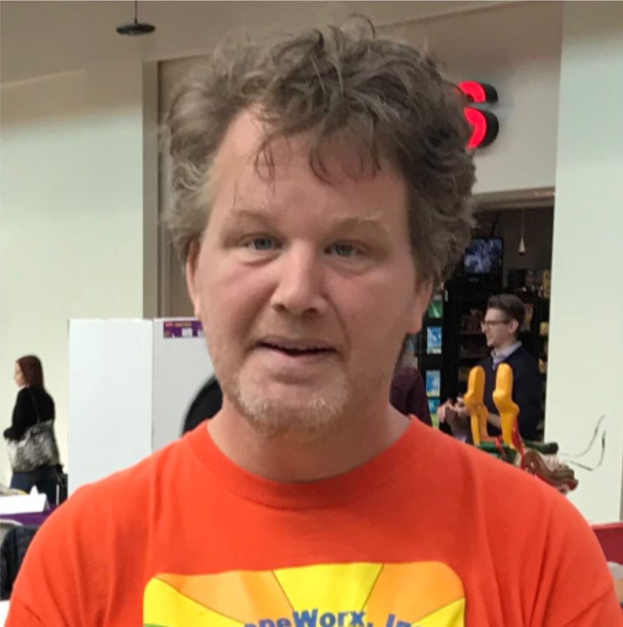  Bryan Stoffregen
  Dion Despaigne |   Jeanne Kanin | 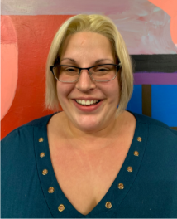  Julie Whitmore
  Larry DePietropaolo |   Lisa Petriello | 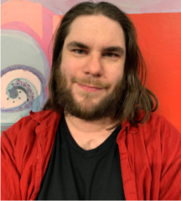  Morgan Killian-Moseley
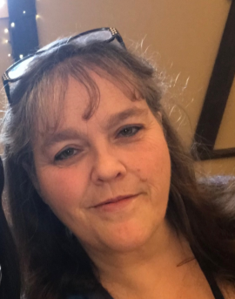  Penny Johnson | 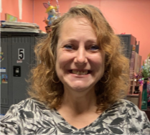Sherri Leco | 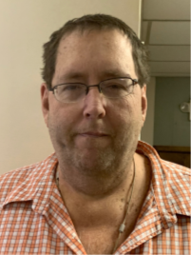  Steve Tompkins

Survey Process

Scope of Work & Creating Survey Tools
The survey tools are developed based on the annual scope of work provided by the county office contact to CST. In addition we are connected to a project point person at the county who gives the team an overview of the assigned project. We also get feedback and questions from people who have had experience with the mental health system, providers, and the results from previous survey reports.

Contacting Providers & Conducting Interviews
The Montgomery County Office of BH/DD expects CST and mental health providers to work together to facilitate a process for one on one surveys between CST staff and people who use services. CST strives to be flexible and accommodate the schedules of the people we survey – we can do surveys in the evening or on the weekend if that is the time that works best. We can also make an appointment and meet a person in the community to do a survey if a group survey time is not convenient for that individual. In addition to meeting with people in the community, we also conduct surveys over the phone when necessary.

All surveys are done anonymously. The interviews are conducted in a location that is private to encourage honest feedback\conversations. While CST encourages everyone to participate, all of our surveys are completely voluntary and we never pressure anyone to participate. We do offer a $5 stipend for participation.

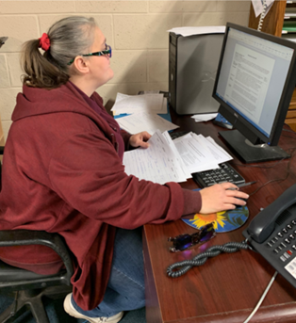
Compiling, Analyzing Data & Creating Reports

When CST has finished the interviewing process, the data is entered into the SNAP professional 11 database. After the data entry is completed, the team compiles the data results into a report. The team then conducts a quantitative and qualitative data analysis to identify strengths and concerns (areas for improvement), and to make recommendations based on the survey results.
Penny Johnson - working on the Inpatient Hospital survey reports.

Sharing Information with the Stakeholders

Executive reports are created based on the sites visited as well as aggregate summaries, which are shared with the Montgomery County Office BH/DD and the providers. The reports are also available to anyone who is interested in reviewing them.

Providers are encouraged to share the reports with staff and the people who use services.

In addition to the survey reports, CST sends out a “Closing the Loop” survey to the provider agencies. The “Closing the Loop” survey is an opportunity for providers to share their feedback about the survey process and results/reports. The CST staff also use it as a tool for improvement when on future surveys.

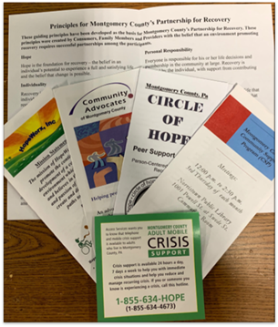
2018 SCOPE OF WORK

CST Projects
In 2018 the CST staff interviewed 310 people while working on four projects:
- Community Hospital Integration Program and Services (CHIPPS)
In addition to interviewing people we also share information about different community supports.
- Career Centers
- In-Patient Psychiatric Hospitals
- Assertive Community Treatment (ACT) Team.
Below is a summary for each project as well as the results of the state questions that are included in each questionnaire.

Community Hospital Integration Program and Services (CHIPPS)

Overview
Every year on the CST scope of work is the survey of residential programs funded by Community Hospital Integration Program and Services (CHIPPS). CHIPPS funding is intended to fund services for people who previously were in the state hospital or who have been diverted from the state hospital as it has downsized. CHIPPS funded residential programs are designed to offer a range of supportive services. The primary goal of these residential programs is to prepare residents with the array of skills, supports, and resources needed to maintain their own independent community housing.

Scope
CST developed the survey tool consisting of 53 questions (both multiple choice and open-ended), with sections to cover information about:
- Demographics  - Residential Staff interaction  - Residential Support/Treatment Team  - Community Supports  - Employment | - Computer Access  - Residential Program  - Roommates  - Independent Living  - Office of Mental Health State Questions

The team conducted interviews with the available residents from 23 residential sites. The residential sites each fall into one of the six different levels of care:
- Full Care/Moderate Community Residential Rehabilitation (CRR)  - Licensed Personal Care Homes (PCH)  - Specialized Co-occurring Program | - Specialized Supported Residential  - Supported Living, Long Term Structured Residence (LTSR)  - All-Inclusive Residence (AIR)

The purpose of the CHIPPS survey is to assess the satisfaction of the people living in the residential program every year.

Quarterly Summary
In the 1st quarter, the team finished the data entry and started analyzing the data collected for the CHIPPS 2017 survey.

In the 2nd quarter, members of the CST staff continued reviewing the raw data and generating executive summaries for each site and the levels of care for the 2017 CHIPPS survey. The team also started working on developing the new CHIPPS survey tool for 2018. The 4th draft of the 2018 survey tool was completed and shared with our Office of BH/DD liaison David Jackson, Performance Management Coordinator/Program Specialist II and Drew Carter, Quality and Performance Manager for feedback. By end of the 2nd quarter the team finished developing the 2018 CHIPPS survey tool and the team started scheduling site visits for the 2018 -19 survey cycle.

In the 3rd quarter, the team worked on finalizing the 2017 CHIPPS reports. At the end of the 3rd quarter the team sent out the 2017 CHIPPS reports for 23 residential sites along with their associated level of care and a copy of the aggregated report to our Office of BH/DD liaisons and the providers of the each site. They continued to conduct interviews, work on data entry, and start data analysis for individual sites with five or more people interviewed. At the end of the 4th quarter the team worked on generating site reports and aggregate summaries for each level of care.

In the 4th quarter of 2018 the team worked on finishing our executive summary reports and emailing them to our Office of BH/DD liaisons and mailing them out to the CHIPPS providers. In addition, we have included our “Closing the Loop Survey”, which allows the providers to share feedback about the survey reports. Below is the aggregated executive summary report for the 2018 CHIPPS survey results.

CHIPPS Survey Results Summary
Below is a list of residential sites visited and categorized by the level of care. The team also added the capacity of each site and how many people were surveyed. Please note that the capacity listed is not necessarily the number of people residing at the time of the survey or the number of people available at the time of the survey. We use convenience sampling, which allows the team to interview anyone who is available at the time of the survey and would like to participate.
 |  | 2017 | 2018
Community Residential Rehabilitation (CRR) | Capacity | Total surveyed | Total surveyed
Circle Lodge | 24 | 14 | 14
Creative Health - King St. | 12 | 4 | 6
Hatfield House | 10 | 8 | 4
RHD - New Foundations - CRR | 7 | 1 | 3
RHD - New Foundations - Yale | 8 | 4 | 4
RHD - Positive Resolutions – Haws Ave. | 5 | 4 | 4
Salisbury Behavioral Health – Milestones - 9 York Road | 15 | 6 | 8
CRR Total | 81 | 41 | 43
Licensed Personal Care Homes (PCH) | Capacity | Total surveyed | Total surveyed
Merakey – 478 Bethlehem Pike | 8 | 3 | 3
RHD - New Options 1 | 13 | 11 | 8
Salisbury Behavioral Health – Roslyn | 13 | 5 | 9
Salisbury Behavioral Health - Gypsy Lane | 4 | 3 | 1
Salisbury Behavioral Health – Glenside – Apt. 626 | 9 | 3 | 3
PCH Total | 47 | 25 | 24
Specialized Co-occurring (SC) | Capacity | Total surveyed | Total surveyed
Pennsylvania Institute for Community Living (PICL) | 15 | 12 | 10
Renaissance | 20 | 13 | 11
SC Total | 35 | 25 | 21
Specialized Supported Residential (SSR) | Capacity | Total surveyed | Total surveyed
Carelink | 9 | 2 | 6
RHD - Positive Resolutions - Middleton | 10 | 4 | 2
RHD - Positive Resolutions - DeKalb St. | 6 |  | 4
RHD - Positive Resolutions - Freedly | 6 | 6 | 3
RHD - Positive Resolutions - Fornance | 4 |  | 1
RHD - New Options 2 | 5 | 2 | 3
SSR Total | 40 | 14 | 19
Supported Living (SL) | Capacity | Total surveyed | Total surveyed
Creative Health - Keim St. | 15 | 9 | 6
Salisbury Behavioral Health – Glenside Apartments - 614 | 23 | 14 | 9
SL Total | 38 | 23 | 15
Long Term Structured Residence (LTSR) | Capacity | Total surveyed | Total surveyed
Creative Health - LTSR | 16 | 11 | 8
All Inclusive Residence (AIR) | Capacity | Total surveyed | Total surveyed
Horizon House/AIR | 8 | 6 | 6
Aggregated Total | 265 | 145 | 136

Demographics
Participants in the survey are adults 18 years and older who are living in the CHIPPS residential programs funded by Montgomery County Office of BH/DD / HealthChoices.

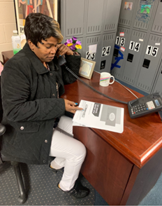

Strengths
- 89% of the people surveyed said overall, they were very satisfied (n=64) or satisfied (n=57) with the residential program staff.
- 85% of the people surveyed felt that living at the residential program is very helpful (50%) or helpful (35%) to their mental health recovery.
- 83% of the people surveyed said they felt their cultural differences are always being respected by the residential program.
Anise Robinson reviewing the CST annual report.
- 82% of the people surveyed said they rated the overall residential program as excellent (49%) and good (33%).
- 84% of the people who said their support/recovery/treatment team, is supportive of their decisions and life goal choices.

Concerns (Opportunities for Improvement)
- 69% of the people surveyed said the staff at the residential program always treat them with dignity and respect.
- 64% of the people surveyed said the staff at the residential programs are always sensitive/understanding regarding people's challenges/triggers.
- 31% of the people surveyed said yes (17%) or sometimes (14%) they have had to make a choice they were not comfortable with at the residential programs.
- 79% of the people surveyed said they always feel safe where they are living.
- Over 30 people said they did not have a support/recovery team, and only 11 people said they have been at their residential program 2 months or less.

CHIPPS Survey Highlights
Support and Encouragement
People were asked, “Does the staff support and encourage you to do things that are meaningful to you?” and 73% of the people surveyed said the staff at the residential program always supports and encourages them to do things that are meaningful to them. In addition, they were also asked, if staff believe in their ability to recover, and does the staff play a role in their recovery. 78% of the people surveyed said the staff at the residential program believes in their ability to recover and 64% of the people surveyed said yes staff plays a role in their recovery.

Chart 4: Support and Encouragement of residential staff over the past four years.
Chart 5: Reflects the responses of people who felt that the staff at the residential program not only supports and encourages them to do things that are meaningful to them, but the staff also believe in their ability to recover.

Support/Treatment Team
103 people said they had a Support/Treatment Team. Out of the 103 people 79% of them said they met with their treatment team regularly and 21% said they do not meet with their team regularly. When they were asked, “Do you feel like an equal part of their treatment team?” Chart 6 - shows people’s responses to this question.

In addition to looking at the people who had a treatment team, CST wanted to highlight that there are a number of people living at the residential program over three months and have said they do not have a treatment team (see table below).
Length of time living at the  residential program | Percentage of people who said they did not have a support/treatment team
3-6 months (n=27) | 7%
7-12 months (n=18) | 16%
1-2 or more years (n=80) | 32%

Community Supports/Activities of Daily Living
People were asked what mental health supports and natural supports/social activities do they use out in the community to help them in their recovery and the top four responses were:
Mental Health Supports | Natural Supports
Outpatient Services (Therapy, IOP, etc.) - 56% | Family - 79%
Recovery Coach - 48% | Friends/ Peers - 69%
Certified Peer Support - 38% | Going to the mall/shopping - 63%
Community/Self-Help support groups - 22% | Restaurants - 57%

70% (n=95) of the people surveyed said they can go out into the community as often as they liked. However, 17% (n=24) of the people said they go out somewhat often, 10% (n=13) said not as often as they like, and (n=4) 3% said they did not want to go out into the community. When asked, “If you do not go out in the community as often as you would like, what are some of the reasons why?” The top responses for the reasons were transportation, financial issues, the symptoms of mental health illness and staff availability. Even though there some challenges to getting out in the community, 75% of the people surveyed said they are given the choice about where they want to go in the community.
Reasons people do not go out in the community
Transportation – 38%
Financial issues – 36%
Symptoms of mental health illness & Staff availability – 23%

The question “Do you have job?” was asked and the results were examined based on the aggregate reports for the past three years, Chart 7 - shows a comparison of the responses.

Residential Program Helpfulness
When asked to rate how helpful living at the residential program is to their mental health recovery,
50% of the people surveyed said it is very helpful and 35% said it is helpful. For 2017 somewhat helpful was not included in the answer grid.
Satisfaction Rating
When asked to rate the residential program overall, out of 136 of the people surveyed 49% said excellent and 33% said good. Chart 9 – shows the response to the overall rating for the past three years (2016 – 2018).

CHIPPS State Questions Responses
In the last 12 months, were you able to get the help that you needed?
Yes (always) | 104 (77.0%)
Sometimes | 28 (20.7%)
No (never) | 3 (2.2%)

What effect has the treatment you received had on the quality of your life?
Much better | 63 (46.7%)
A little better | 43 (31.9%)
About the same | 26 (19.3%)
A little worse | 1 (0.7%)
Much worse | 2 (1.5%)

Were you given the chance to make treatment decisions?
Yes (always) | 91 (67.9%)
Sometimes | 31 (23.1%)
No (never) | 12 (9.0%)

Career Center Services

Overview
The Career Center providers focus on people using mental health services who want to work.
The Career Center providers help to support each person with career and educational goals. In the fiscal year 2013-2014, CST conducted surveys at the Career Centers funded by the Montgomery County BH/DD office. The team completed 99 surveys at 10 sites Central MH/MR, Creative Health Services, Northwestern Human Services (NHS), Goodwill, Gateway, and Hedwig House (in Pottstown, Norristown, Lansdale, and Abington). For the fiscal year 2017-2018 scope of work, CST was asked to conduct a follow-up satisfaction survey. For this assessment, the team will be surveying six Career Centers, which includes:
- Merakey  - Goodwill  - Creative Health Services | - Lower Merion Counseling Services  - Central Norristown  - Central Abington

The purpose of the survey is…
- To assess the level of improvement from 2013-2014.
- To determine individual perception of whether they are closer to their goal of employment than they were prior to engagement.
- To measure whether evidence-based practices are adopted (how readily was support accessed, were career goals centered on the individual’s interests, etc.)
- To measure the impact of the services on the individual’s life.
- To determine individual perception of how the level of service improves wellness and whether the individual feels supported in achieving their goal of employment.

Scope
The survey tool development was based on input from CST staff, as well as information from the Montgomery County BH/DD office project liaison - Maureen Feeny-Byrnes, Coordinator of Peer Support Services. The team met with Maureen Feeny-Byrnes in April 2017 to discuss and answer any questions the team had about Career Center services.

The Career Center services are mainly community based. To reach the population for this survey the CST Team will be working on arranging site visits and phone calls with each Career Center supervisor. The team discussed the survey process and assessed the best approach to conduct the interviews with the people served at each Career Center, since they have different operational styles.

To be eligible for the survey, the target population should have used or be currently using one of the Career Centers listed above. This would include people who have used the Career Centers Services and…
- are currently working, and/or
- have stopped using Career Centers Services and are not working.

Career Centers Quarterly Summary
In the 1st quarter of 2018, the CST Team continued to work on reaching out to the Career Centers supervisors to schedule survey interviews and/or to get the list of people served with their contact information. We discussed with each Career Center supervisor what the best approach would be to accommodate each site and to reach the people served. However, the team was faced with some challenges in reaching the people who are using or have used the Career Centers services:
- Because the service is mainly community based, it is difficult to get a group of people in one place.
- Flyers inviting people to contact CST were sent out via the supervisors and we had a very low response rate.

The CST received a list from Maureen Feeny-Byrnes of all the people who used Career Center services in the past three years, but the list did not contain contact information. The team reached out to the Career Centers requesting the contact information for the people they serve. However, each site contact stated that due to the HIPPA laws they were unable to give us a list of names and contact information. However, Goodwill did agree to mail out a letter on our behalf to people on the list. We were unable to make further progress towards contacting previous service users from other sites because we do not have contact information. After a second meeting with Jennifer Radick, Employment Services Manager at Goodwill, by the end of the 1st quarter we were sent a list with contact information. This was after they reviewed their county contract. Going into the second quarter the team are contacted people from the Goodwill list by phone.

Along with interviewing people from Goodwill, in the 2nd quarter, the CST staff continued to reach out to the Career Centers supervisors to collaborate on sending survey flyers to people who had used the service in the last 3 years. Creative Health Services Career Center mailed out flyers to the people they serve and only 2 people called in to complete a survey. The table below outlines the survey progress at the end of the 2nd quarter.
Career Center Sites | # of people on each list | # of people surveyed | Notes
Central - Abington | 75 | 3 | Got an updated list but no contact information
Central - Norristown | 188 | 16 | Got an updated list but no contact information
Creative Health | 0 | 3 | Got an updated list but no contact information, and flyers were sent out inviting people to call CST.
Goodwill | 142 | 40 | Got an updated list with contact information and flyers were sent out inviting people to call CST.
Merakey | 0 | 9 | Flyers were sent out inviting people to call CST
RHD/LMCS | 40 | 1 | Got an updated list with contact information and flyers were sent out inviting people to call CST
Total | 445 | 72

In the 3rd quarter of 2018, CST decided to put the Career Centers survey on hold to work out the concerns about HIPAA Privacy Rule and ROI. The team met with David Jackson, who created a letter to share with the providers to address the issue of HIPAA Privacy Rule and ROI.

In the 4th quarter, surveys continued to be on hold while the team waited for the final draft of the letter to address the concerns providers had about Privacy compliance/HIPAA. We have since met with David Jackson, Performance Management Coordinator/Program Specialist II at the Montgomery County office of BH/DD to discuss the issue. David has provided us with a letter which was sent to the providers and us in efforts to help our partnership and the efficiency of the survey process.

In October 2018 the team received an updated list of 43 people from Lower Merion Counseling & Mobile Services, with contact information (phone numbers and addresses). Going into the 1st quarter of 2019 the team will be reaching out to Central and Merakey with the letter from the county office and to start interviewing people again.

In-Patient Psychiatric Hospitals

Overview
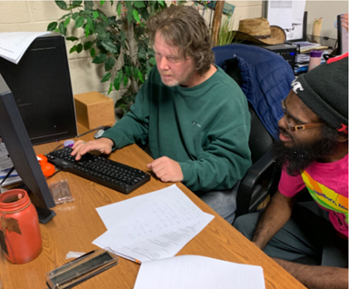
Every year the Consumer Satisfaction Team (CST) of Montgomery County conducts surveys at four Montgomery County In-Patient Psychiatric Hospitals:
- Brooke Glen
- Horsham Clinic
- Montgomery County Emergency Services (MCES)
- Pottstown.
From left - Bryan Stoffregen & Dion Despaigne working on Inpatient Hospital Executive Summary.
In-Patient Psychiatric Hospitals provide services to people experiencing a serious mental health crisis and/or at serious risk of hurting themselves or others. The services encompass voluntary or involuntary psychiatric assessment and treatment. In addition, continued stay in the hospital is reviewed as needed daily depending on medical necessity. The services focus on stabilizing and facilitating recovery needs/skills to help people regain wellness and return to the community.

The purpose of the survey is to gather information about the level of satisfaction from the people who have received services at these hospitals. The survey for the 2017-2018 fiscal years focused on:
- The recovery principles  - Crisis planning  - Access to services in the community  - Recovery planning | - Community supports  - Staff interaction  - Level of satisfaction with services

Scope
Participants in the survey are adults (18 years & older) who have been in the hospital for three days or more, and are there voluntarily, and are also a Montgomery County resident. The sample sizes for each hospital are as follows:
Brooke Glen -16 people | Pottstown – 10 people
Horsham Clinic – 22 people | MCES – 30 people.

The survey tool was developed by the CST staff, who have lived experience with Montgomery County mental health services, with feedback from County Office of Mental Health staff. The team also reviewed the previous year’s survey results, and feedback from the provider closing the loop surveys. Interviews were conducted between October 2017 and January 2018.

In-Patient Psychiatric Hospitals Quarterly Summary
In the 1st quarter of 2018, the team finished interviewing at the inpatient hospitals. The survey is designed for people who are voluntarily committed. However, the team has also been interviewing people who are involuntarily committed and would like to participate in the survey. The requirement for the participants is that they have been in the hospital from 5 to 7 days and are involuntarily committed. The data collected is compared to the responses from the people who are voluntarily committed.

To ensure the data collected is accurate, the hospitals have been very accommodating with providing the team with a list of people who are within the survey criteria. They also indicate who is voluntarily or involuntarily committed. In the 2nd Quarter, the CST staff compiled the survey data and started making reports for each hospital as well as an overall report.

In the 3rd quarter of 2018, the team worked on developing the survey tool for the 2018 – 19 survey cycle.

Before the team started interviewing the people using the In-Patient Psychiatric Hospitals, we met with and/or had emailed conversations about how to best work together. We discussed how we can work efficiently with scheduling and accommodations. We were also able to ask and respond to questions and concerns directly, which added value to our partnerships and the survey process. Due to some staff development and meeting with the providers there was more communication and the survey process was smoother for this cycle.

The team started interviewing in mid-October. In the 4th quarter, the team interviewed 84 people voluntarily committed at the Inpatient Hospital services. Based on some feedback from both CST staff and the people we interviewed there was a spike in the number of people who said they came to the hospitals because they were unable to get access to rehab services they needed for D&A. In the 1st quarter of 2019 we will work on finishing interviews and data entry. We will also be analyzing the data collected and developing an executive summary.

In-Patient Psychiatric Hospitals Survey Results Summary 2017 -18
For the 2017-2018 survey cycle the team interviewed 86 people at the In-Patient Psychiatric Hospitals. The questionnaire consisted of 50 questions, which included nine (9) sectional topics:
- Demographics  - Crisis Plan/Access to Services  - Admission  - Recovery Plan  - Staff | - Activities/Down time  - Supports  - General Questions  - Office of Mental Health State Questions

Hospitals | Initial sample size | Number of people surveyed
Brooke Glen | 16 | 16
Horsham Clinic | 22 | 34
MCES | 30 | 27
Pottstown | 10 | 9
Total | 78 | 86

Demographics
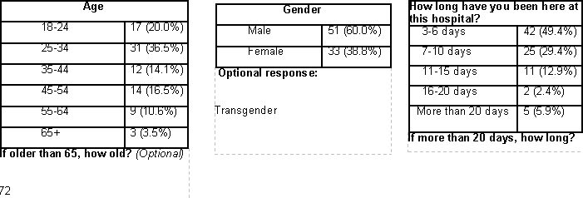

Survey Results Summary
Below is an executive summary for the people interviewed in the 2017-2018 In-Patient Hospital survey. The Consumer Satisfaction Team interviewed a total of 86 people and the team would like to highlight the following points based on the aggregated results of the survey:

Strengths
- 82% of the people surveyed said that they were treated with dignity and respect all the time when they were being admitted.

- Overall, 81% of the people surveyed felt like an equal part of their treatment/recovery planning process. 61% of the people said they were listened to and their ideas were incorporated. 20% of the people said they made compromises on plans/ideas that are best for them.

- 79% of the people surveyed felt that they are being given the treatment that they needed for their recovery. Some feedback from the people surveyed were:
- “I’m being listened to and they are incorporating my goals.”
- “Yes, they are setting me up at Central with a team.”
- “Every time I leave, I feel better than I did.”

- 81% of the people surveyed said they would recommend the hospital to someone who needed mental health help. Some of their comments were:
- “They seem to care.”
- “This is a good place.”
- “The people show a lot of concern and care.”

Concerns (Opportunities for Improvement)
- Out of the 67 people who said that they have been to a hospital before, 74% of those individuals said that they did not have a crisis plan before coming to the hospital.
- Overall, 65% of the people surveyed said they were given a choice about their medications, and 27% said the effects of their medications were not explained in a way that they could understand.

- Only 52% of the people surveyed felt that staff is sensitive about things that may trigger people while at the hospital all the time. In addition, when asked if they had an issue or concern with staff, 36% of the people surveyed said that, they felt it is always resolved appropriately. Some comments were:
- “Grimness is expressed.”
- “Verbal altercation about how they talk to me.”

- Only 31% of the people surveyed said they knew how to use the services of the Ombudsperson here for a rights concern or to make a complaint and 57% of the people said they did not know what an Ombudsperson was.

Mental Health Services Connection
Chart 10 - is showing the responses of the 55-people who indicated that they are connected to mental health services outside the hospital.

Level of Satisfaction
Very/Somewhat Satisfied - Of the 86-people surveyed 68 (79%) said they were very satisfied 48 (56%) / somewhat satisfied 20 (23%) with the services they received at the hospital. Of 68-people, who said they were very/somewhat satisfied, 91% (n=62) said they would recommend the hospital to their friends and family if they needed mental health services.

Very/Somewhat Dissatisfied - Of the 86-people surveyed only 3 (3%) people said they were very dissatisfied 2 (2%)/somewhat dissatisfied 1 (1%) with the services they received at the hospital. Of the 3-people who said they are very/somewhat dissatisfied one person said that maybe they would and two people said they would not recommend the hospital to their friends and family if they needed mental health services.

Trauma Informed Care Questions
The Consumer Satisfaction Team included many questions in the 2017 -18 In-Patient Hospital survey that addressed the six guiding principles of Trauma Informed Care as defined by SAMHSA. Here is our breakdown of these principles and what we found in our survey:
- Safety
  - Only 74% of people reported that they felt safe all the time at the hospital.
    - Comments that highlight this concern:
      - “Except when we get unwanted sexual attention and have men walking in women hallways.”
      - “I hear things that are going on.”
      - “Arguments, pulling fire alarm.”

- Only 52% of people felt that staff is sensitive about things that may trigger people all the time. This is an area for opportunity for improvement.
    - Comments that highlight this concern:
      - “They are very rude.”
      - “I wish staff were able to understand what I am going through.”
      - “They are not compassionate to my needs or meds.”
- During admission, 82% of people reported that they were treated with dignity and respect all the time and only 6% of people said that staff did not address their questions and concerns.

- Trustworthiness and transparency
  - Confidentiality was an area of concern. Only 71% of people surveyed were very confident that the information they shared was kept confidential.
    - Comments that highlight this concern:
      - Overheard staff talking about me, sometimes others.
      - One staff person was not confidential about someone else
      - Sometimes you hear them talking shit about patients and laughing
      - I see them point to people and laugh while talking to other staff

  - When asked whether concerns or issues with staff are resolved appropriately, only 25% of people said Sometimes or Never, but the comments were disturbing.
      - They stay trying to get each other out of trouble. They work together.
      - Nurses do what they want and are rude.
      - They act as if they do not know anything.
      - Told to wait for something and never get it.

- Peer Support and Mutual Self-Help

- Collaboration and Mutuality
  - When asked “Do you feel like an equal part of your treatment/recovery planning process?” only 6% of people surveyed said no, which is a strength.

  - When asked if they were given a choice about medications, 34% of people surveyed said no, or sometimes. 27% of people surveyed said that the effects of their medications were not explained in a way that they could understand.
    - The following comments highlight this concern:
      - They did not ask me.
      - Was forced meds when first arrived? Had a reaction to medication.
      - No explanation was given.
      - They did not tell me the side effects of meds.
      - Not at all and I had an allergic reaction.
      - Do not talk about unless you ask.

Chart 15 - Highlighting the relationship between people’s choice, education about medication and getting the help they need for their recovery while in the hospital. The graph is reflecting the responses of people from for the past three years, who have said:
- They have been given a choice about medications,
- The effect of their medication was explained in a way they understood,
- And they felt like they were given the treatment they need for their recovery.

- Empowerment, voice and choice
  - 92% of people surveyed said that they had never been made to do anything they did not want to by staff.
  - Only 31% of people surveyed knew that there was an Ombudsperson and how to make a complaint, and only 46% of people knew that there are Advocates and knew how to contact them.

- Cultural, Historical and Gender Issues
  - 72% of people surveyed reported that they are always treated with dignity and respect by staff. This is an area for improvement.
    - Comments that highlight this concern:
      - They get frustrated and start acting disrespectful.
      - Sometimes some of the staff will hold grudges and will mess with you.
      - They do not listen to me.
      - Some people need more attention, so be more observant.
      - They say what they want to say to you. They do not do anything but talk about us.
      - I might need something, they are busy, tell me to wait. It never is done. Bring home problems into work and take it out on the patients.

Assertive Community Treatment (ACT) Team

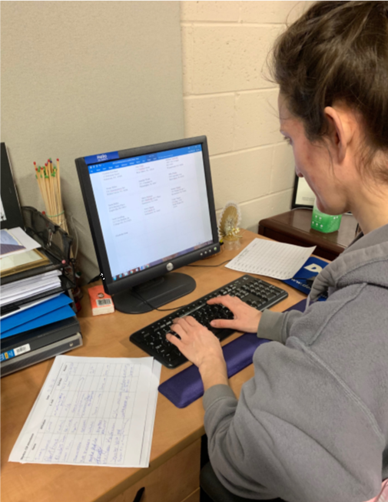
Overview
The Consumer Satisfaction Team of Montgomery County (CST) was ask to conduct surveys at the Montgomery County Assertive Community Treatment (ACT) Teams, which are Horizon House of Norristown and Penn Foundation of Pottstown and Sellersville.

The ACT teams provide services to adults 18 and older with serious persistent mental illness and co-occurring disorder. The program utilizes a multi-disciplinary team approach to providing services to individuals in their communities. The team consists of a psychiatrist, nurses, mental health specialists, drug and alcohol specialist, employment and peer specialists.
Anja Elgroth – working on data entry.

The purpose of the survey is to gather information to assess the level of satisfaction from the people who have used or are using the ACT Team services. The survey for the 2018-2019 fiscal year will:
- Assess the level of improvement from the last survey which was done in 2010.
- Determine individual perception of whether they are closer to achieving their goals and wellness.
- Measure whether the ACT team evidence-based practices are adopted (how readily was support accessed, were career goals centered on the individual’s interests, etc.)
- Measure impact of the services on the individual’s life.
- Determine individual perception of how the level of service improves wellness and whether the individual feels supported in achieving their goal of employment and independence in the community.

Scope
The survey tool was based on past and current experiences and knowledge of the Assertive Community Treatment teams from the Consumer Satisfaction Team staff, who themselves are customers of Montgomery County’s Mental Health services, as well as results from previous years’ reports, and from our County contacts: Michele Son and David Jackson. The team also invited an individual who is currently using the ACT service to share their experience and give the team some feedback about developing the survey tool.

Participants in the survey were individuals who used (in the past and present) the services of the ACT teams of Horizon House and Penn Foundation. There was no set sample size.

ACT Quarterly Summary
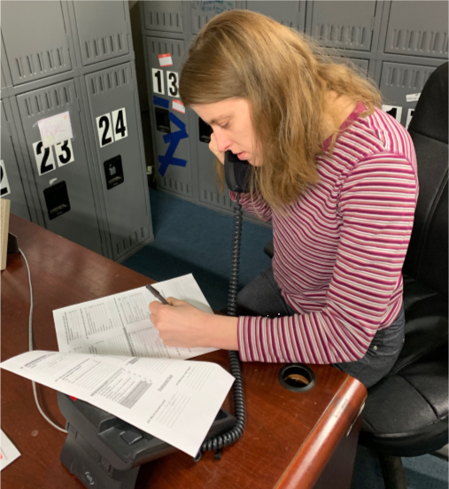
In the 3rd quarter of 2018, the team worked on developing the survey tool for the 2018 – 19 survey cycle. The team received a list of people who have used the ACT Team. CST staff developed a letter to be mailed out to everyone on the list, to inform them about the survey and who CST is, and inviting them to contact us to complete the survey.

In the 4th quarter of 2018, the CST staff finalized the ACT survey tool. The team also mailed out the letters/flyers to inform the people who have used or are using ACT services. We also continued to interview people who have called in to complete the survey. The team completed 14 surveys between all three ACT Teams and while doing so we ran into a few challenges around contacting people because they did not have a regular phone contact – the phone number provided was for the ACT team offices. To address this issue going forward, we will be setting up meetings with the ACT Team directors to have a conversation about how we can work together to reach the people they serve.
Lisa Petriello – doing an interview over the phone.

2018 State Questions Results

Quarterly Responses to the State Questions
Every survey the team conducts we are required to ask three state questions:
- In the last 12 months were you able to get the help that you needed?
- What effect has the treatment you received had on the quality of your life?
- Were you given the chance to make treatment decisions?
The responses to these questions and project/s progress are sent to the county office quarterly. See Chart 17 - for the 2018 quarterly report for the state questions results.

Source: Montgomery County Consumer Satisfaction Team, Reported Data 2014-2018 ©
Adult Mental Health Consumer Satisfaction reached a 5 year high for all three state satisfaction questions. Responses to both "In the last 12 months were you able to get the help that you needed?" and "What effect has the treatment you received had on the quality of your life?" were in the high agreement range, 85% and 83% respectively. Responses to "Were you given the chance to make treatment decisions?" were in the moderate agreement range at 69%.

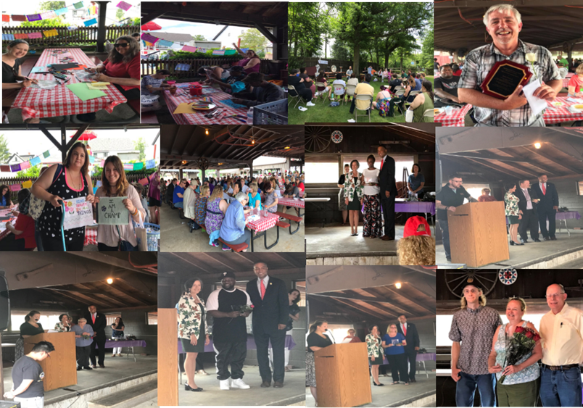
COMMUNITY SUPPORT PROGRAM (CSP)
2018 Annual Montgomery County CSP Conference and Mental Health Award Reception Highlights.

CST & CSP Working Together
CST is the fiduciary for the Montgomery County CSP and Southeast Regional CSP Committees, responsible for coordinating the monthly meetings, administering the budget and providing technical and administrative support for Montgomery County & Southeast Regional CSP activities, including minutes distribution, producing the CSP newsletter, coordinating the annual art contest, and coordinating the annual Montgomery County CSP conference and Southeast Regional Retreat.
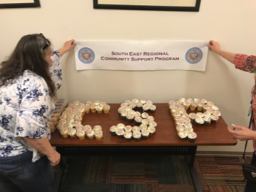 | 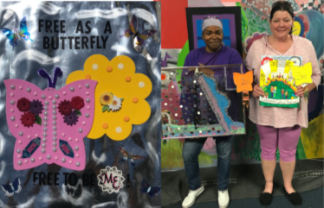 | 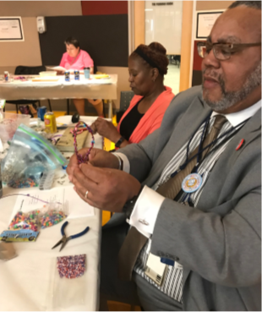
Jewelry making session at the SE Regional Retreat
Montco. CSP Art Contest winners
SE Regional Retreat at RHD in Philadelphia

2018 CST Staff Development
Some of the trainings and community events CST staff participated in during 2018 are:
- Advocates Against Hunger – volunteered at Produce Distribution, participated in strategic planning process  - Benefits and Employment  - Building Skills for Self-care  - Community Advisory Council  - Norristown Community Garden  - Guest speaker at the Pathways program at Behavioral Health Court  - Harrisburg Rally Bus trip  - Host karaoke and Mural at CHOC  - Human Services Community Advisory council  - Interagency Council of Norristown (ICN)  - Introduction to Adult Mental Health Services  - Kevin Hines-Cracked not Broken  - Letter writing for Coalition against Hunger  - Magellan stakeholders meetings  - Montco. Bar Association Access to Justice Summit  - Montco. Women’s Reentry Initiative | - Montgomery County Hearing Voices Network, including “An Evening with Berta Britz”  - Montgomery County Office of MH/DD/D&A Advisory Board  - Montgomery County Wellness Fair  - Motivational Interviewing  - NAMI walk  - OMHSAS Advisory Committee – Sunshine attendees  - Partnered with Waste Not Community Exchange Co-op.  - PDN Learning Collaborative  - Peer Advisory Council  - Peer Respite Committee  - Presentation at INAPS  - Risking Connections  - Stepping Up Initiative committee  - Suicide prevention Task Force  - Trauma collaborative  - Trauma Trainings 1-4  - Understanding Voice Though a Recovery Perspective

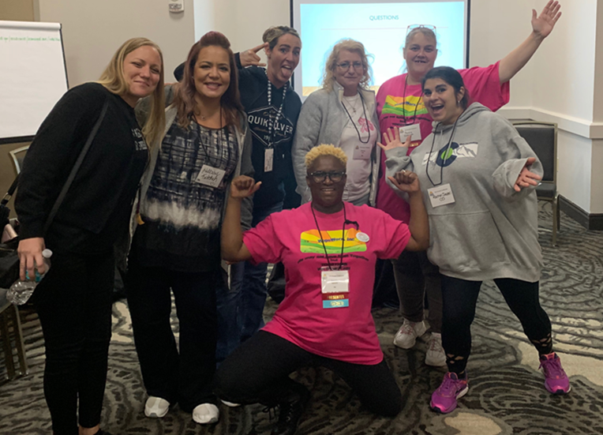
Ameika Malcolm and Penny Johnson at the INAPS conference in Orlando, FL.

They did a presentation on – “Creating a peer run environment for growth and connections”

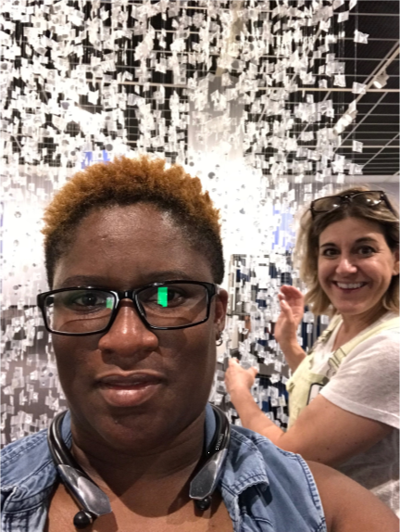 | 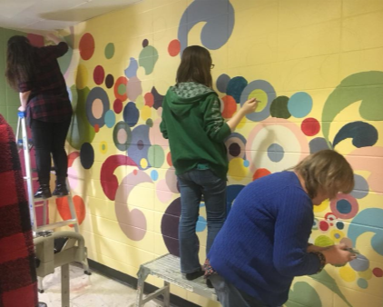 | 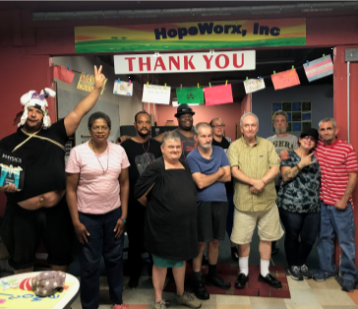
HopeMarket Community Member saying “Thank You” to Stephen Colbert
Working with the CHOC residents on their mural.
HopeWorx partnered with Maria Maneos Brush with the Law on

CST SWOT Analysis

Moving Forward
At the beginning of each fiscal year the CST does a goal planning session as well as continuous staff development throughout the year. By doing this we are able to assess the CST base on Strengths, Weaknesses, Opportunities, and Threats (SWOT).
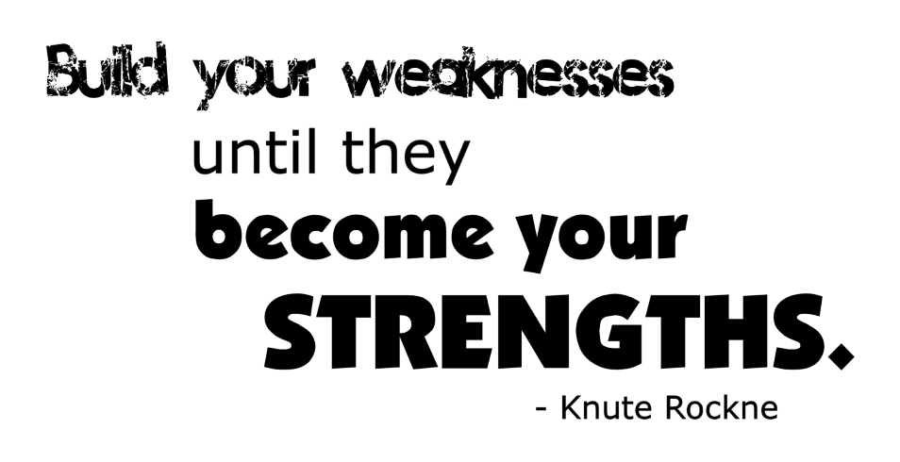
Strengths  - Currently, we are able to meet people where they are at  - There are no wrong doors  - Organic peer support  - Flexibility  - Self-Advocacy  - Diversity in Experiences | Opportunities  - Community Outreach  - Educational Workshops  - Developing Community Partnerships
Weaknesses  - Reaching the Latino communities or other groups with language barriers  - Connecting to the LGBTQ communities  - Scientific Statistical Analysis of data | Threats/Challenges  - Lack of CST awareness  - Reaching people who use community based/mobile services  - Provider partnerships and information  - Closing the Loop – Getting feedback from providers and County office

sOURCE
Guiding Principles of Trauma-Informed Care - https://www.samhsa.gov/samhsaNewsLetter/Volume_22_Number_2/trauma_tip/guiding_principles.html

